Sometimes religious emails are better than some of the funny ones we get and pass on....

Priceless.
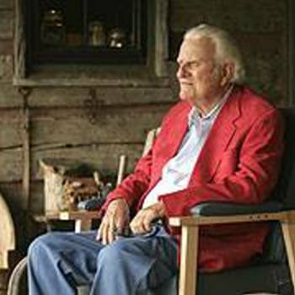
Billy Graham was returning to Charlotte after a speaking engagement and when his Plane arrived there was a limousine there to transport him to his home.
As he prepared to get into the limo, he stopped and spoke to the driver.
'You know' he said, 'I am 87 years old and I have never
driven a limousine. Would you mind if I drove it for a while?'
The driver said,
'No problem. Have at it.'
Billy gets into the driver's seat and they head off
down the highway.
A short distance away
sat a rookie State Trooper operating his first speed trap.
The long black limo went by him doing 70 in a 55 mph zone.
The trooper pulled out
and easily caught the limo
and he got out of his patrol car to begin the procedure.
The young trooper walked up to the driver's door
and when the glass
was rolled down,
he was surprised to see
who was driving.
He immediately excused himself and went back to his car
and called his supervisor.
He told the supervisor,
'I know we are supposed
to enforce the law....
But I also know that
important people are
given certain courtesies.
I need to know what
I should do because
I have stopped a
very important person.'
The supervisor asked,
'Is it the governor?'
The young trooper said,
'No, he's more important
than that.'
The supervisor said,
'Oh, so it's the president.'
The young trooper said,
'No, he's even more
important than that.'
The supervisor finally asked,
'Well then, who is it?'
The young trooper said,
'I think it's Jesus,
because he's got Billy Graham for a chauffeur!'
Smile - God loves you! I ask the Lord to bless you, as I pray for you today;
to guide you and protect you, as you go along your way
God's love is always with you, God's promises are true.
And when you give God all your cares, you know God will see you through

